4. Составь вместе с Пином связные предложения.
1) likes, in, to, newspaper, the, read, mother, evening, my;
_________________________________________________________________
2) computer, Saturdays, on, games, my, plays, sister;
_________________________________________________________________
3) you, hands, eat, do, wash, you, your, before;
_________________________________________________________________
4) after, like, football, we, lessons, to, play;
_________________________________________________________________
5) bed, I, make, the, in, don’t, my, morning.
_________________________________________________________________

5. Пину задали домашнее задание. Помоги ему решить примеры и записать ответ по-английски.

1) forty nine + one = ____________________________________________________
2) ten + fifty six = ______________________________________________________
3) thirty five + sixty five = _______________________________________________
4) fourteen + seventeen = ________________________________________________
5) eighty six + three = ___________________________________________________
6) one hundred and eleven + four = _________________________________________
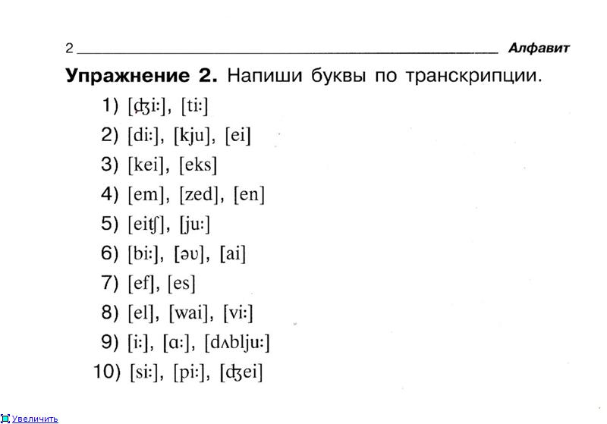
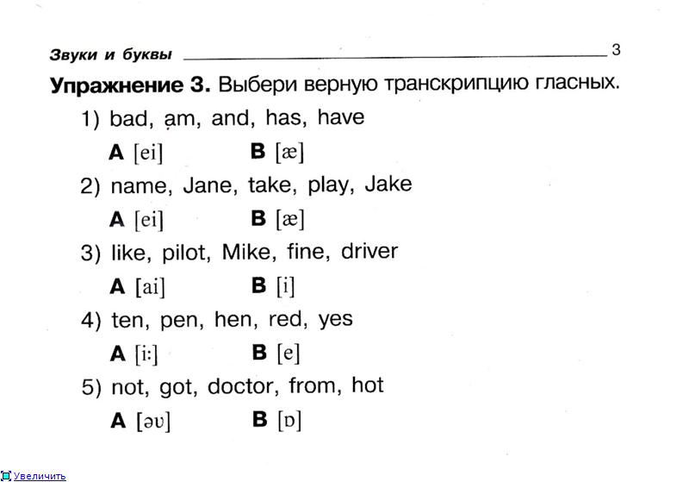
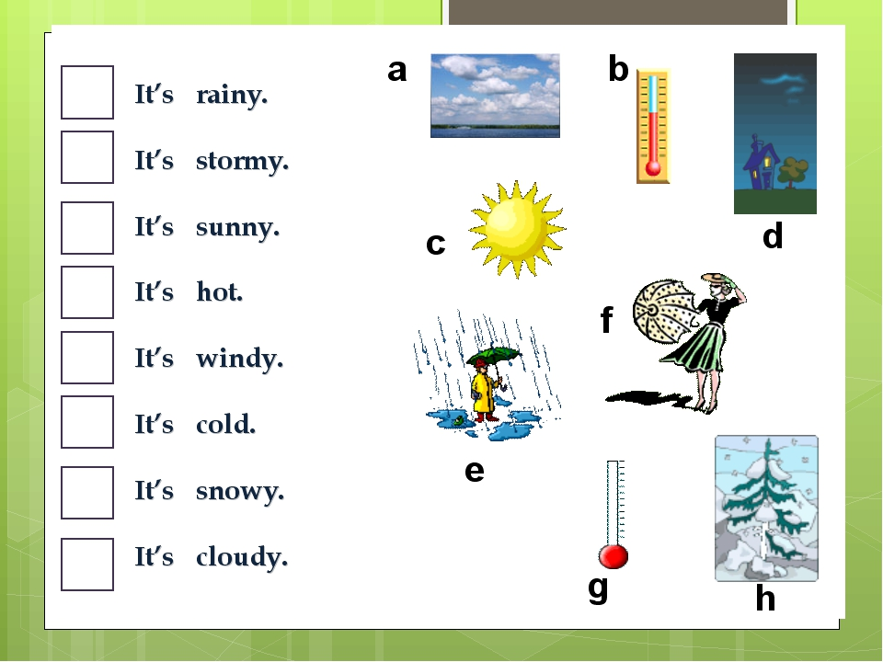
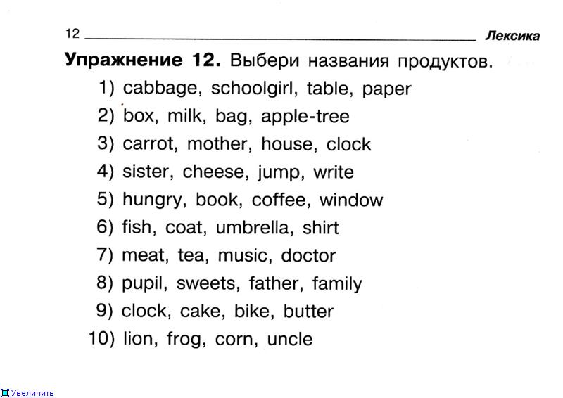

4. Give short answers. (Дайте короткие ответы)
1) Do you go to school every day?
2) Can you play computer?
3) Can your brother swim?
4) Has your mother got a book?
5) Does your friend wash the dishes?
6) Are there two bedrooms in your flat?
7) Have your parents got roller-skates?
8) Is there a kitchen in your flat?

